A Level Photography Summer Assignment
Task 1: use either the camera on your phone or your DSLR (if you have one) and take 8 – 10 photographs of examples of ‘vanishing point’ perspectives in nature-based landscapes. If you have access to apps / digital editing software, then please use this to edit them to make them more visually powerful, try to include black & white edits if you can with some extra contrast to stop them looking too grey.
Examples of vanishing point ‘perspectives in nature-based landscapes
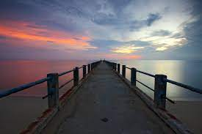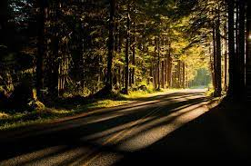
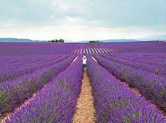
Task 2: use either the camera on your phone or your DSLR (if you have one) and take 8 – 10 photographs of close up images in nature. Crouch down and look through the plants to achieve a sense of depth instead of standing over the plant and looking down on top of it. Edit these if you have relevant Apps / Software.
