A Level Mathematics Year 1 Summer Revision Task

You should already be familiar with each of these topics from school (they are all higher tier GCSE topics).

A deep understanding of algebra, geometry and problem solving from GCSE are necessary to be successful in your first year of A Level Mathematics. Hence, we will be testing all students on these skills in your first lesson to assess your suitability for A-level maths.

On the next few pages are some revision questions for you to complete. You should work through each section and have your solutions ready to hand in to your Maths teacher on the first lesson in the autumn term.

Below are some links to some suggested revision websites that may help:

https://www.mathsgenie.co.uk/gcse.html
https://www.mathedup.co.uk/gcse-maths-takeaway/
https://corbettmaths.com/contents/
https://www.physicsandmathstutor.com/maths-revision/gcse-questions-edexcel/

Have a great summer and enjoy working through these problems!

If you have any further questions regarding the course then please e-mail me: daniel.anderson1@ncclondon.ac.uk

Section 1: Indices and Surds
1.
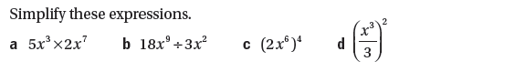
2.
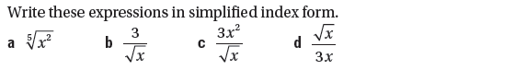
3.
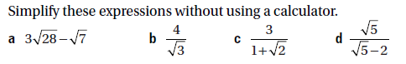

Section 2: Equations and Rearranging
1.
2.
3.

Section 3: Factorising Quadratics and Sketching
1.
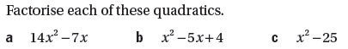
2.
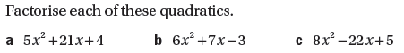
3.
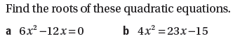
4.
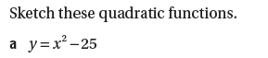
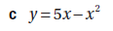

Section 4: Completing the Square
1.
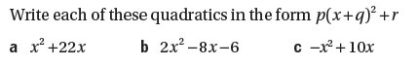
2.
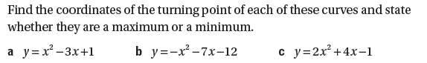
TIP: To determine if the turning point is a maximum or minimum would the curve be a ‘U’ shape or an ‘∩’ shape?

Section 5: Coordinate Geometry
1.
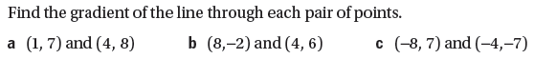
2.
3.
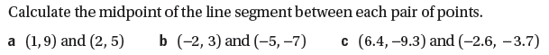
4.
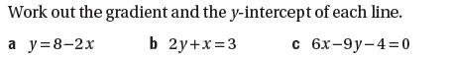
5.
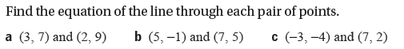
6.
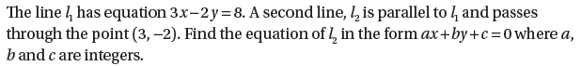
7.
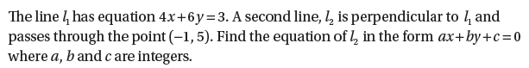
8.

