Summer homework task for history
The following are to be completed over the Summer and submitted in your first History lesson.
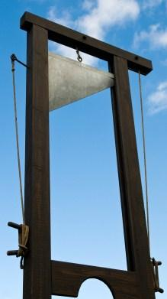
- Fill in the definitions on the glossary sheet.
- Complete the fill in the gaps exercise.
- Write three paragraphs in answer to the question: Can the use of terror be justified?
Paragraph 1: Present one side of the argument.
Paragraph 2: Present the counter-argument.
Paragraph 3: Summarise both arguments and reach a conclusion.
Please note neither argument is wrong but it needs to be justified.
Deadline: First History lesson back.
Fill in the gaps task
Terror in the French Revolution
From 1793-94, the French Revolution went through a period known as the . During this time, the , led by , targeted people within France accused of being . Their sentence, if found guilty, was the . Although there had been notable incidents of violence and bloodshed prior to 1793, namely the in 1791 where Lafayette ordered the National Guard open fire on Republican protestors and, in 1792, the where Parisian prisons were stormed and suspected opponents butchered on the spot. The aim of the Terror was to eliminate political . As was loudly and wildly exclaimed . Two factors which ignited this period of the revolution were and .
Victims of the terror included the former King and Queen .
It was not only royals who were targeted. Priests were specifically persecuted with the most violent example of this being where Priests and nuns were tied together on boats which were then sunk. The Republican army in the led which saw French battalions destroy the houses, crops and property of suspected rebels. The terror ended in July 1794 with the arrest and execution of Robespierre and his supporters.

Words to insert
Robespierre, Hell’s Columns, reign of terror, opposition, Vendée, guillotine, ‘terror is the order of the day’, the Revolutionary War, September Massacres, food shortages, Louis XVI and Marie Antoinette, le noyade, Jacobins, counter-revolutionary, Champs de Mars massacre.

France in revolution, 1774-99: glossary

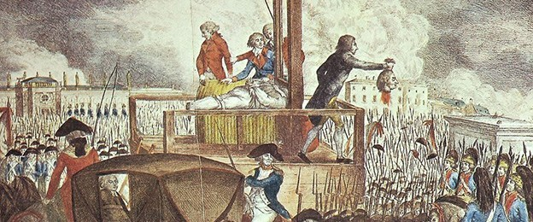

Terror
Reign of Terror
Grain hoarding
The guillotine
The Bastille
Ancien regime
Revolutionary tribunal
De-Christianisation
conscription
The Vendée
Maximilen Robespierre
Olympe de Gouges
The clergy
Jean-Paul Marat
Charlotte Corday
The September Massacres
Aristocracy
The Third Estate
journée
Marquis de Lafayette
A republic
The Jacobins
De Launay
De Doué

