Year 11 Pre course task

For the pre course task we would like you to produce a illustrations / images for stamp designs considering the theme of Exploration and Discovery. Below are a number of starting points.
You can use which ever media you choose or is available to you at home.
IE Computer based, Collage, Paint, Sculpture , Photography, Typography. Your solution could be image or typography based so you could use words. DO NOT USE CARTOONS OR MANGA.

Exploration and Discovery – possible approaches:
- Artists in the 16th century created illustrations of exotic foreign creatures from descriptions alone, descriptions that were recounted by explorers who had actual experience of the creatures. Albrecht Dürer’s engraving of a rhinoceros is one of many classic examples.
- Our senses are bombarded with fresh visual information by events such as holidays, social events, visiting distant relatives, sporting fixtures, trips to galleries and museums Eg science museum), and new friends. Even a simple motorway journey can take you through major contrasts in architecture and landscape.
- Exploration into the microscopic world can transport us to an environment of fantastic organisms with endless shapes and forms. Dissection of the human body reveals the incredible complexity of its mechanics and systems. Dr Gunther von Hagens’s Body Worlds exhibition displayed this fragile beauty.
- Discovering and reading a new book can create pictures of entire communities, environments and individuals in your imagination. It is interesting to see how the film version of a book often provokes a feeling of disappointment. This may be because it is the director’s own visualisation of characters and places, rather than your own.

Here are some more ideas that might help you begin your research based on personal experience, hobbies, visits to places of interest :
● climbing, caving, bird-watching, canoeing, gliding, hiking
● experiments, dissection, dismantling, deconstructing
● exotic food, music, literature
● rock pools, areas underneath stones, dead wood and metal sheets
● zoological gardens, theme parks, fun fairs, museums, libraries
● derelict gardens, cemeteries
● snorkelling and metal detecting
● magnifying lenses, telescopes, binoculars.

Try to select sources which are unusual or challenging, sources which will provide you with a variety of visual stimuli from which you can develop your work.

Outcome -
Stamp design. We would like 3 stamps in a series that link together in some way either through the theme or literally as in the Taiwan stamps on the next page.
Link for stamp design mock up (for use in college).
https://dribbble.com/shots/13478713-Postage-stamps-mock-up-3 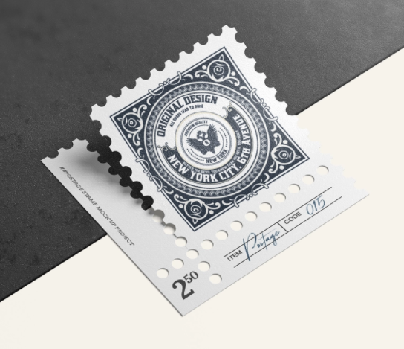
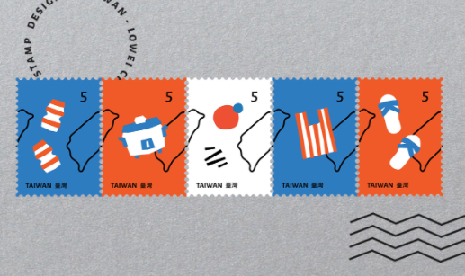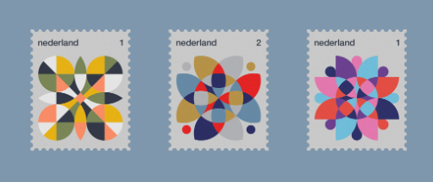

Linking a series
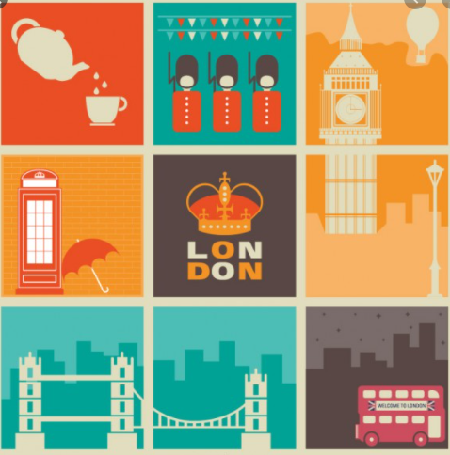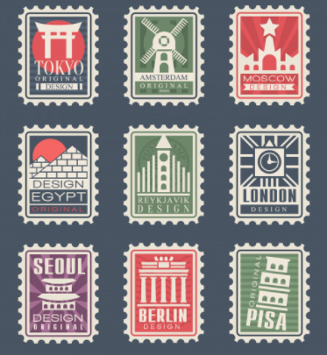

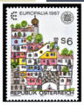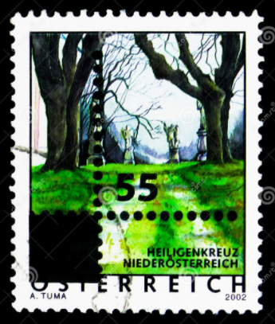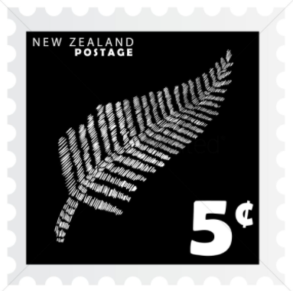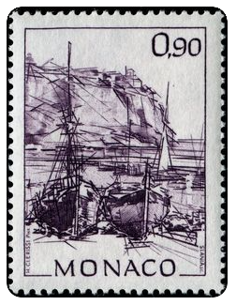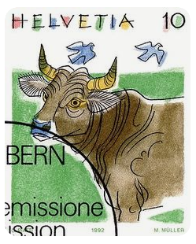
ILLUSTRATION
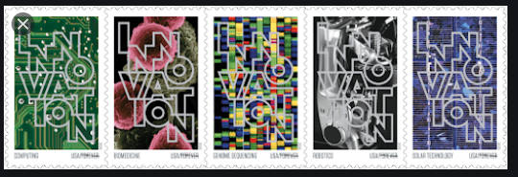 TYPOGRAPHY
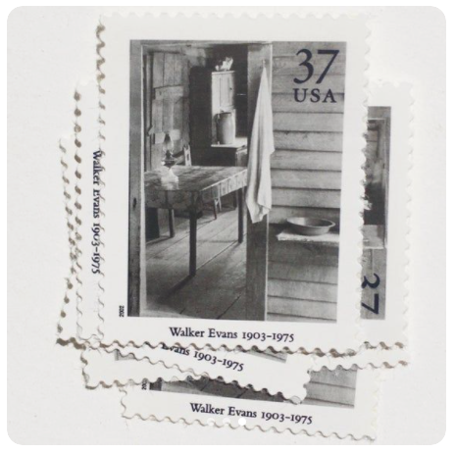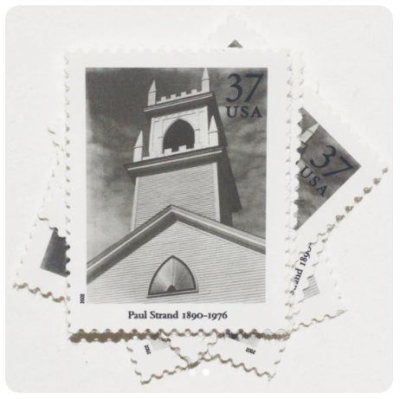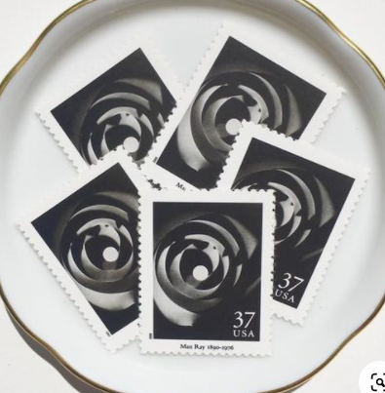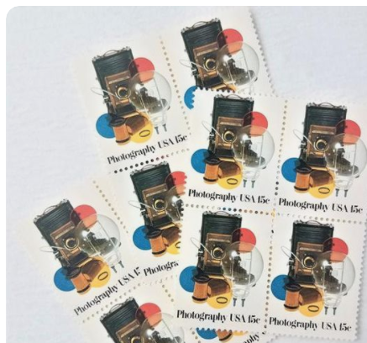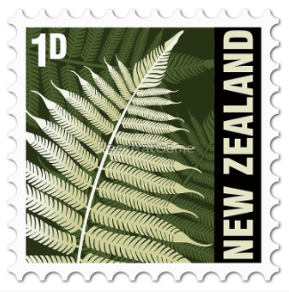
PHOTOGRAPHY

