- Theories overview

Familiarise yourself with the following theories, these are essential when answering long-answer questions
Theory | Brief outline of each theory
Piaget’s stages of cognitive development | Children pass through distinct developmental stages in sequence: the sensorimotor stage from birth to 2 years, the pre-operational stage from 2 to 7 years, the concrete operation stage from 7 – 11 years and the formal operational stage from 11 – 18 years.
Piaget’s schematic development theory | Children use their experiences to construct their understanding of the world around them. Schema are developed through 4 stages: assimilation, equilibrium, disequilibrium and accommodation.
Chomsky’s Language Acquisition Device | The ability to develop signed or spoken language is genetically pre-programmed into individuals. The ability to use language develops because of maturation.
Bowlby’s attachment theory | Infants are biologically pre-programmed to form attachments and infancy is a critical period for forming positive attachments.
Ainsworth’s attachment styles | The quality of a child's attachment is affected by the actions of the parent(s). Attachment can be secure, insecure resistant or insecure avoidant.
Schaffer and Emerson’s stages of attachment | An infant’s attachment develops through 4 stages: asocial attachment, indiscriminate attachment, specific attachment and multiple attachments.
Gesell’s maturation theory | Development is genetically predetermined; environment has little influence. Genetically pre-programmed characteristics and abilities that are not present at birth, develop or ‘mature’ over time.
Bandura’s social learning theory | Learning happens through observing and imitating the behaviour of a role model.
Stress-diathesis model | Some individuals are born with a genetic/biological predisposition to mental health disorders (nature). Stress brought about by life events (nurture) can interact with the genetic/biological predisposition to trigger mental illness.
Parenting styles | A child’s behaviour is influenced by how they are parented. The 4 styles are: authoritative, authoritarian, permissive and uninvolved.
Holmes-Rahe Social Readjustment rating scale | This theory explains the relationship between life events and stress. There are 43 identified major stressful life events; divorce, death of a spouse, mortgage, in-laws trouble, and changing school etc. The social readjustment rating scale (SRRS) measures stress scores for different life events. Although, each individual deals with stress differently, Holmes-Rahe assumed that stress affects people equally.
Social disengagement theory | This theory proposes that older people have restricted opportunities to interact with others. The theory states that disengagement in a natural part of ageing and that it is appropriate and healthy behaviour.
Activity theory | This theory proposes that the social and psychological needs of older people remain the same (i.e. that they do not decrease). The theory proposes that older people can achieve healthy ageing through continued social activity. Older people may continue to be socially active after retirement by taking on new roles, such as charity work, joining social groups or learning a new skill.

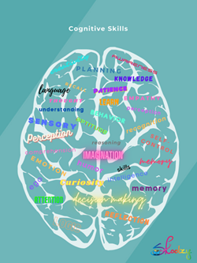
- INTELLECTUAL DEVELOPMENT

You are required to carry out a lot of independent research and reading

- Research on what are Piaget's 4 stages of cognitive development?
  - Piaget's stages of cognitive development | Processing the Environment (youtube) – you also use google search engine for further support.
  - Ensure to include the correct age and explain all 4 different stages of the theory

- What is meant by the following terms; explain the following stages, including the correct age of when it occurs, if possible include relevant examples for each term.:
  - Object permanence
  - Egocentrism

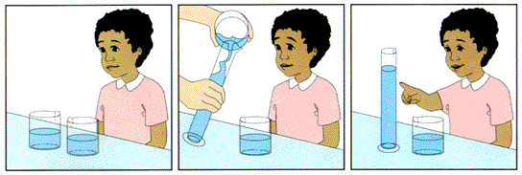

- What does Piaget mean by conservation? At which of Piaget's developmental stages are children able to conserve? Include an appropriate example of when children are able to conserve.

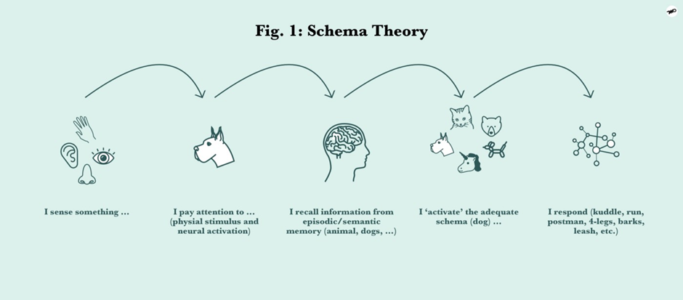

- Watch the video - Development: Schemas, Assimilation, & Accommodation (youtube)
  - What is a schema?
  - Describe how the schemas help us understand the world?

- Can you give 2 criticisms of Piaget's theories?

