Research and answer the following questions (preferably using a biology textbook)

1a) Define Prokaryotic cells:…………………………………………………………

……………………………………………………………………………………………

1b) Bacteria are examples of prokaryotes. The diagram shows a bacterium. Identify the structures labelled A to F and give one function of each.



**A** ..................................... Function.........................................................................

....................................................................................................................................

**B** ..................................... Function..........................................................................

....................................................................................................................................

**C** ..................................... Function...........................................................................

....................................................................................................................................

**D** ..................................... Function..........................................................................

....................................................................................................................................

**E** ..................................... Function............................................................................

**F**...................................... Function..............................................................................

2a) Define Eukaryotic cells:…………………………………………………………

……………………………………………………………………………………………

2b) Animal cells, plant cells and fungi cells are examples of Eukaryotic cells. Label the animal cell and write down the functions of the organelles

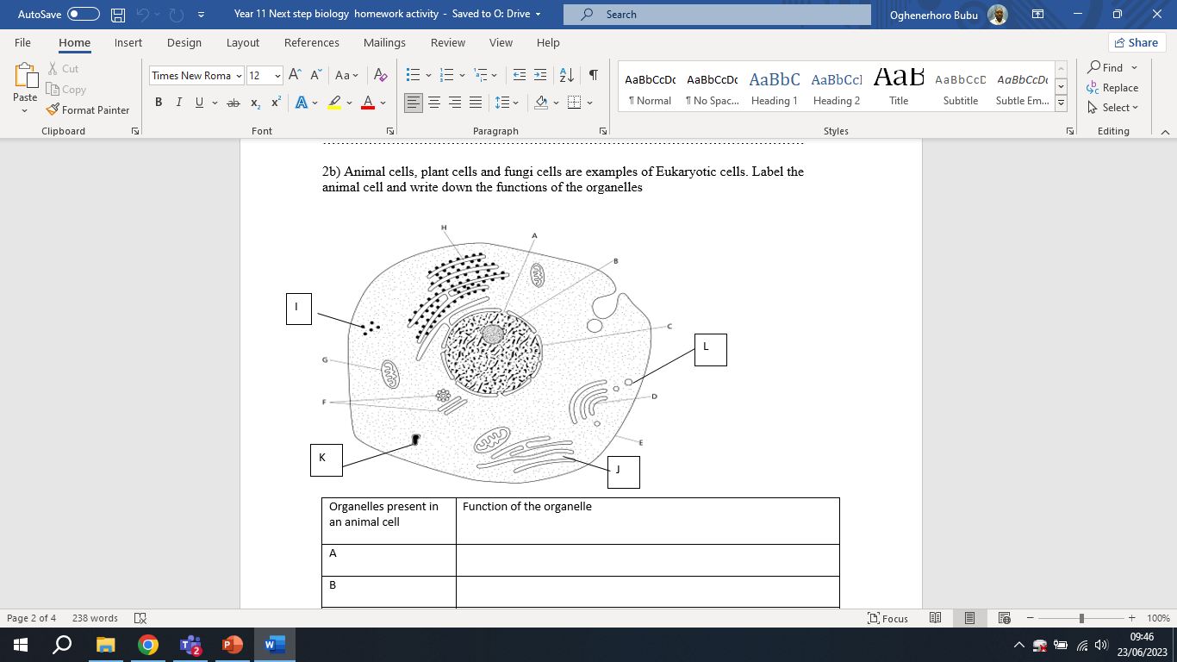

|  |  |
| --- | --- |
| Organelles present in an animal cell | Function of the organelle |
| A |  |
| B |  |
| C |  |
| D |  |
| E |  |
| F |  |
| G |  |
| H |  |
| I |  |
| J |  |
| K |  |
| L |  |

2c) Label the plant cell and write down the functions of the organelles

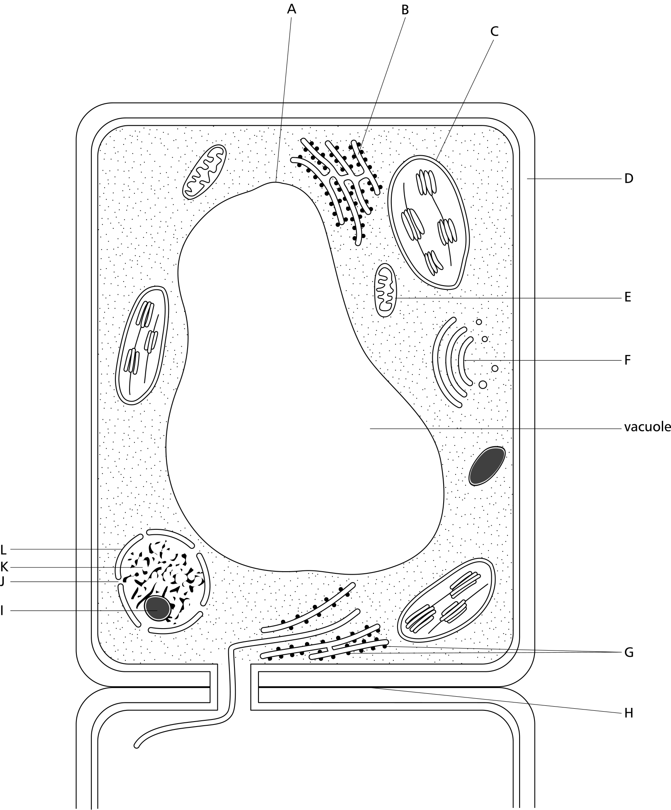

|  |  |
| --- | --- |
| Organelles present in a plant cell | Function of the organelle |
| A |  |
| B |  |
| C |  |
| D |  |
| E |  |
| F |  |
| G |  |
| H |  |
| I |  |
| J |  |
| L |  |

3a) Use the labelled diagrams of bacteria, plants and animal cells to list 3 similarities between prokaryotes and eukaryotes

…………………………………………………………………………………………………………………………………………………………….

……………………………………………………………………………………………………………………………………………………………

……………………………………………………………………………………………………………………………………………………………

3b) Compare and contrast bacteria cell, plant cell and animal cell

|  |  |  |  |
| --- | --- | --- | --- |
| Feature | Bacteria cell | Plant cell | Animal cell |
| Nucleus |  |  |  |
| Ribosome |  |  |  |
| Chloroplast |  |  |  |
| Cell wall |  |  |  |
| Mitochondria |  |  |  |

3c. Cells are microscopic and are usually measured in micrometres. As an A’ level biology student, you need to be confident working with numbers. Practice interconverting units by completing the table below.

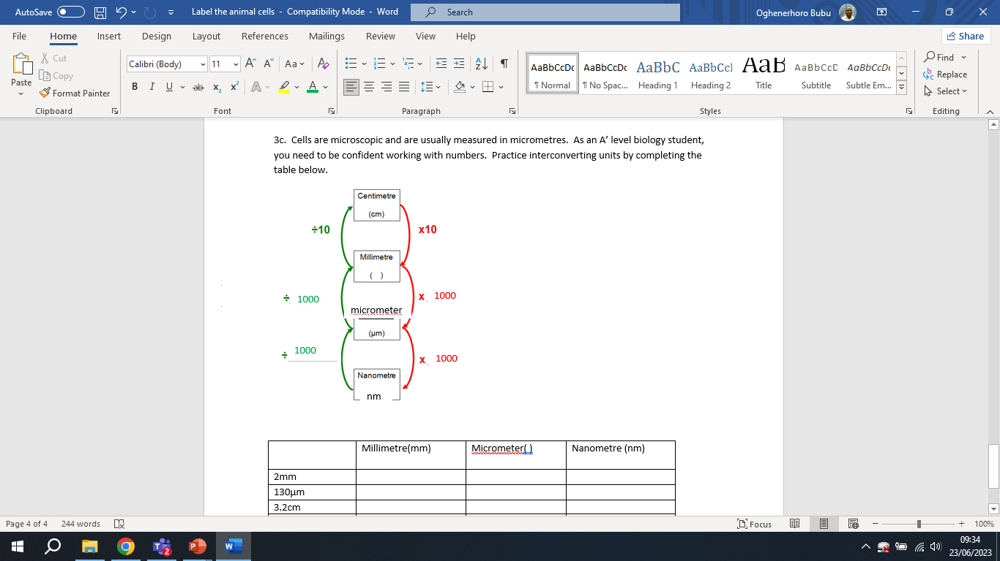

|  |  |  |  |
| --- | --- | --- | --- |
|  | Millimetre(mm) | Micrometer( ) | Nanometre (nm) |
| 2mm |  |  |  |
| 130μm |  |  |  |
| 3.2cm |  |  |  |
| 7.25μm |  |  |  |